Task 1:

Title: A Step-by-Step Guide: Creating and Hosting a WordPress Website on AWS EC2

Introduction:

In today's digital age, having a website is essential for individuals and businesses alike. WordPress, with its user-friendly interface and powerful features, is a popular choice for building websites. When it comes to hosting your WordPress site, Amazon Web Services (AWS) Elastic Compute Cloud (EC2) provides a scalable and reliable infrastructure. In this blog post, we'll walk you through the process of creating and hosting a WordPress website on AWS EC2.

Step 1: Set up an AWS Account To get started, you'll need an AWS account. Visit the AWS website (<https://aws.amazon.com/>) and create a new account if you don't have one already. Follow the registration process, provide the necessary information, and set up your billing preferences.

Step 2: Once your AWS account is set up, log in to the AWS Management Console. Search for EC2 in the services menu, and navigate to the EC2 Dashboard. Click on "Launch Instance" to create a new EC2 instance.

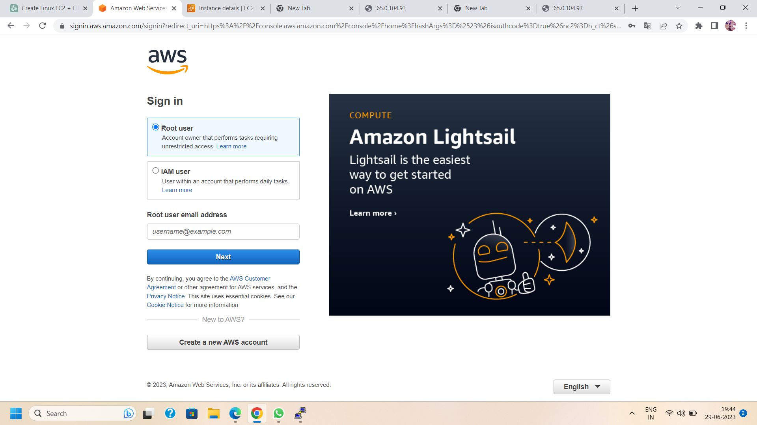

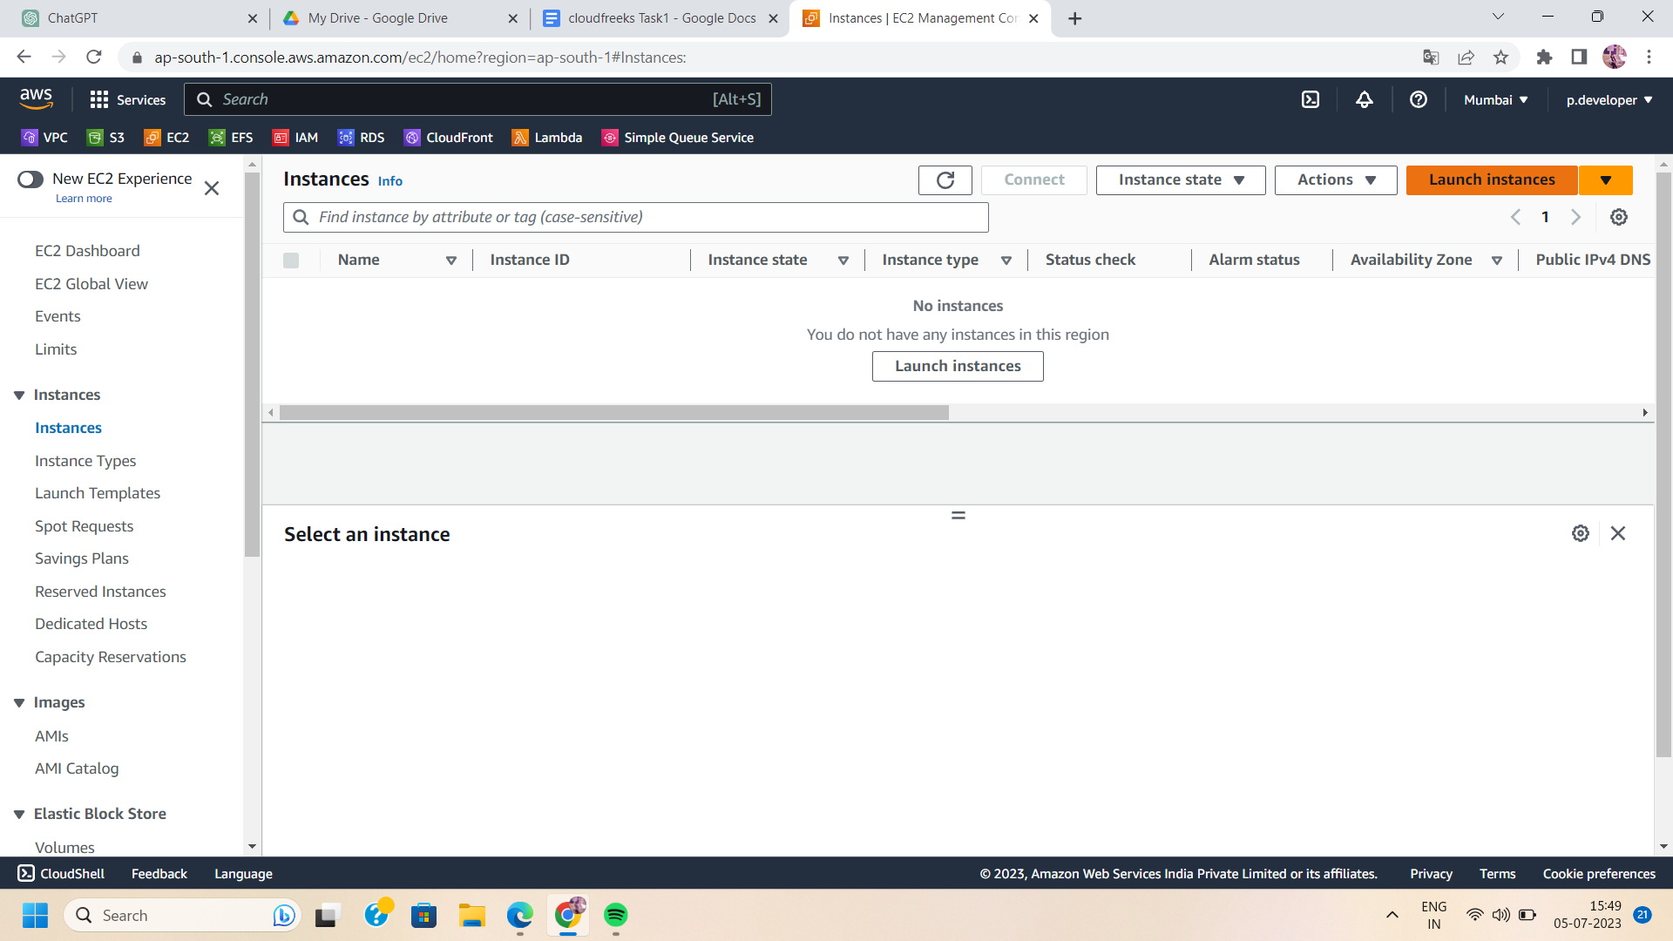

Step 3: Launch a new EC2 instance using Amazon Ubuntu AMI (or you can choose your own AMI which is compatible with Wordpress).

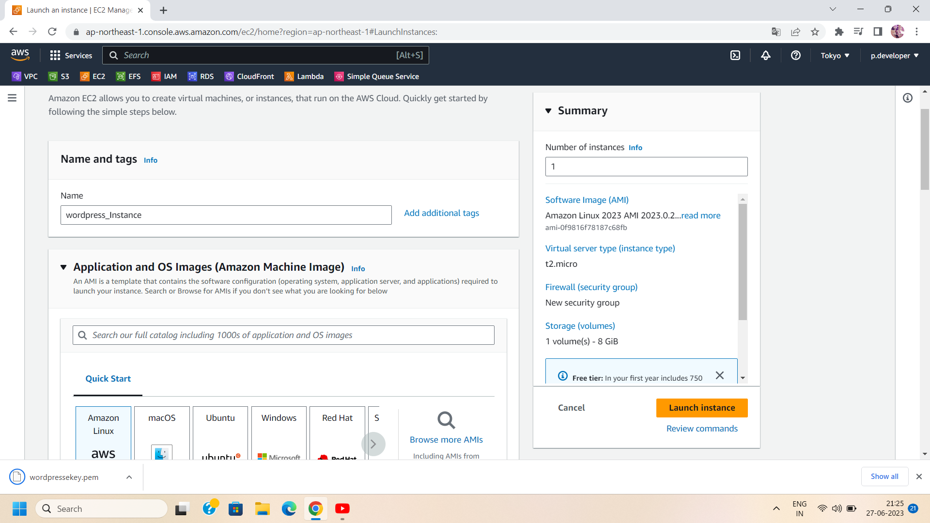

1. Choose the desired instance type, storage, and other configuration options.
2. During the EC2 instance setup, configure the security groups to allow inbound traffic on ports 80 (HTTP) and 443 (HTTPS) so that your website can be accessed publicly.

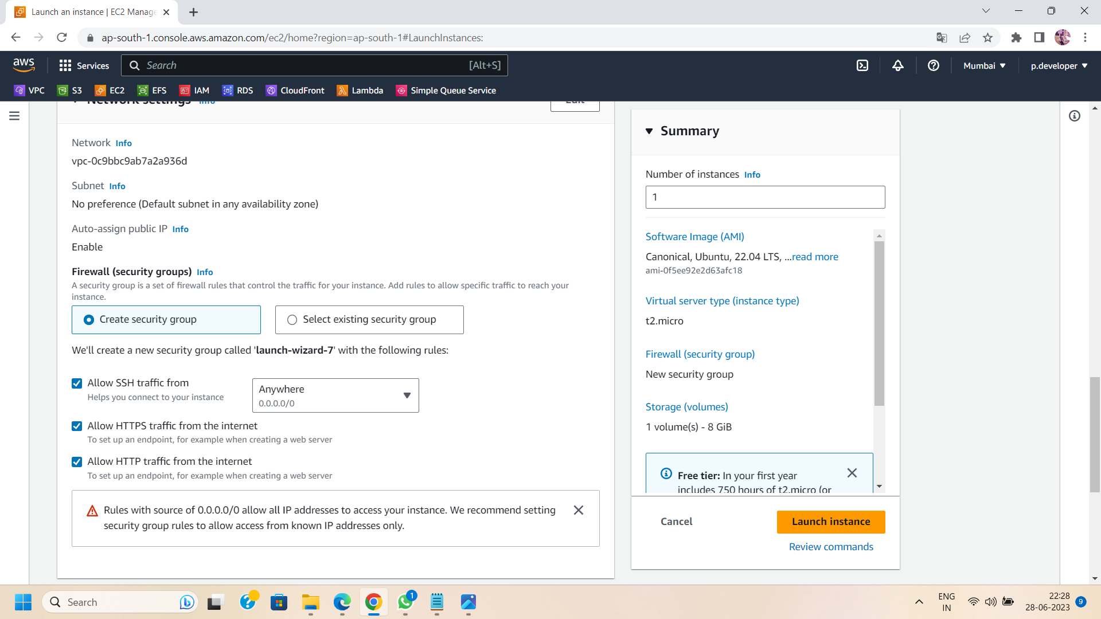

Step 4: Allocate an Elastic IP address to your EC2 instance. This provides a static IP address that you can associate with your domain name.

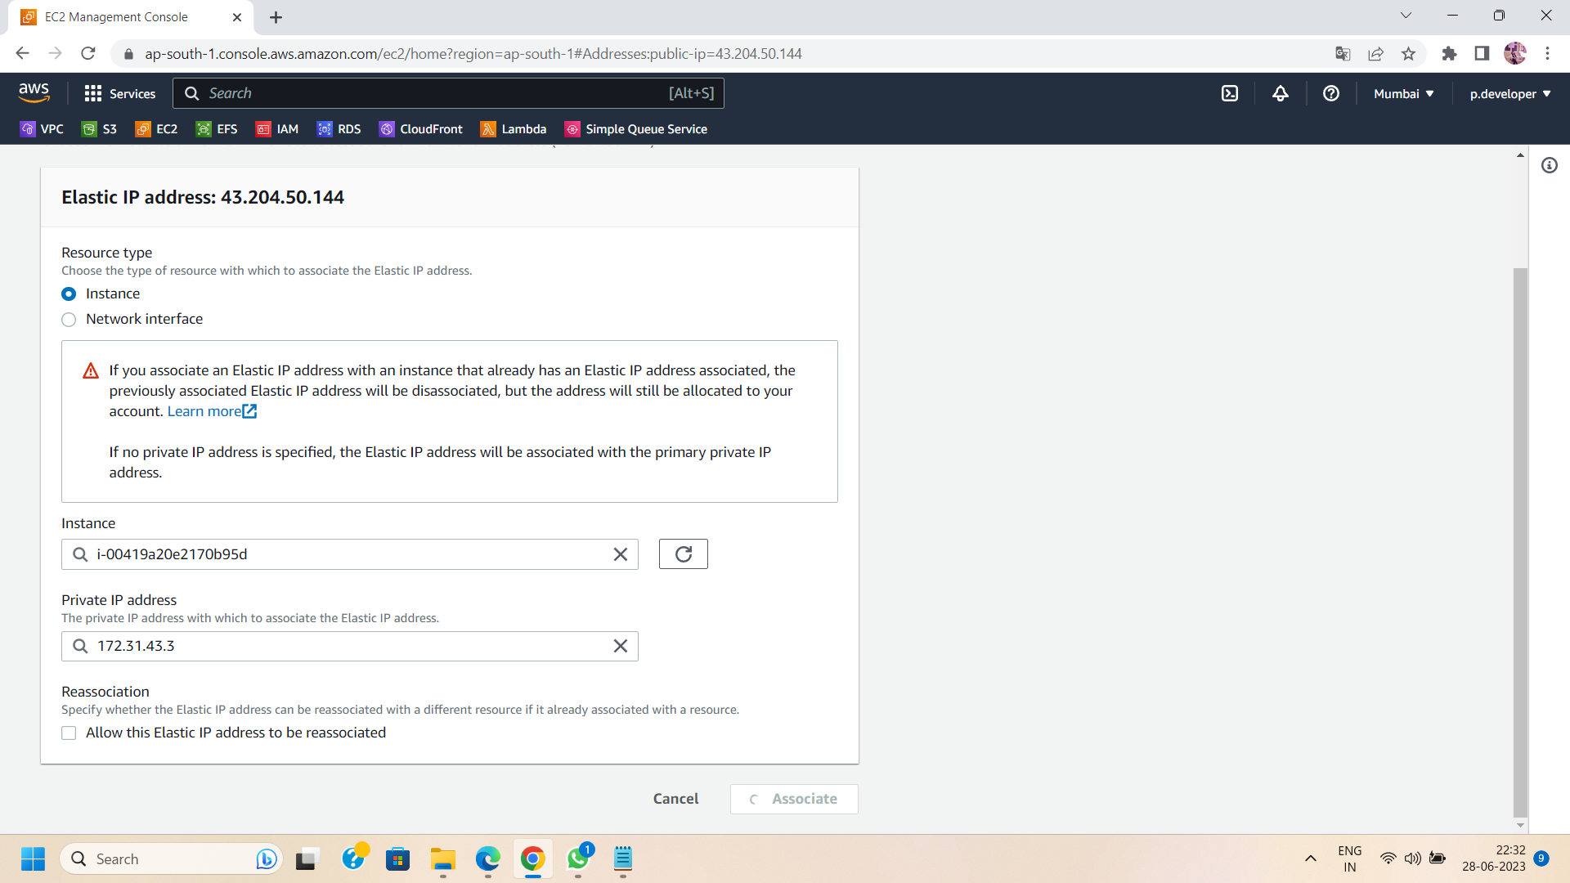

Step 5: Take SSH to connect your EC2 instance from your local machine.

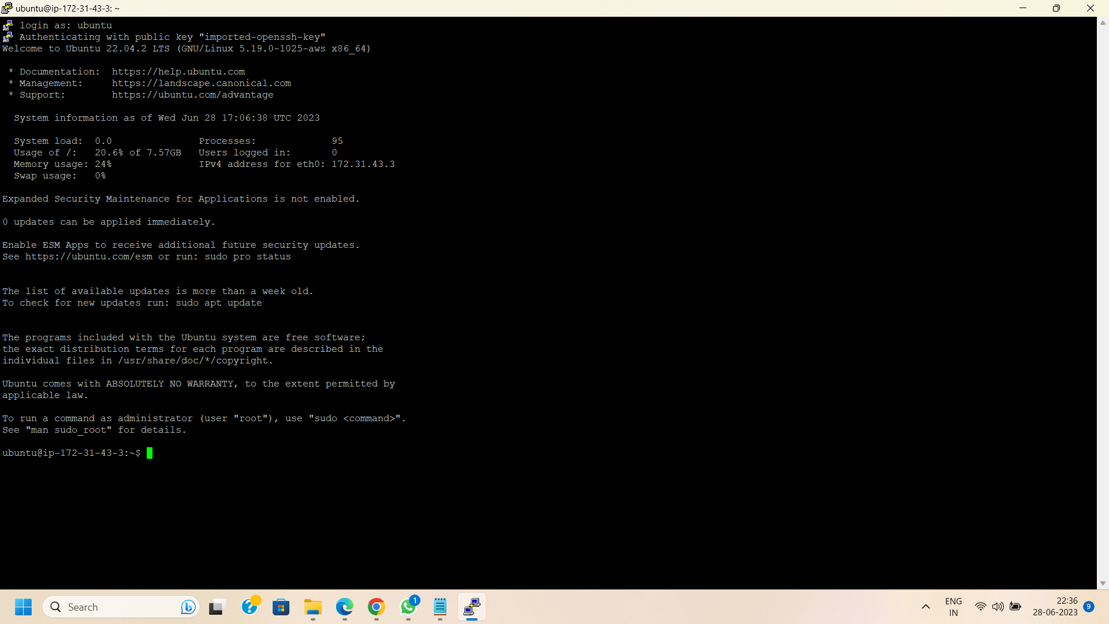

Step 6: Now login as “Ubuntu” username and then run the following commands :

**1.Install Apache server on Ubuntu**

sudo apt install apache2

Your default apache server is now available on the browser.You can checkout using your elastic IP address (e.g.,<http://52.66.37.142>) .

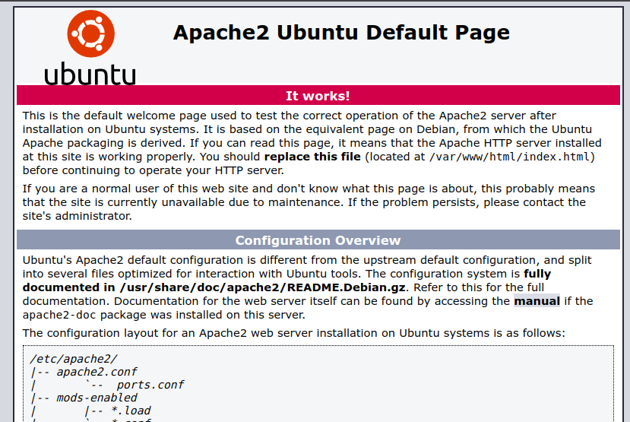

**2. Install php runtime and php mysql connector**

sudo apt install php libapache2-mod-php php-mysql

**3. Install MySQL server**

sudo apt install mysql-server

**4. Login to MySQL server**

sudo mysql -u root

**5. Change authentication plugin to mysql_native_password (change the password to something strong)**

ALTER USER 'root'@'localhost' IDENTIFIED WITH mysql_native_password by 'CloudfreeksWorld@123';

**6. Create a new database user for wordpress (change the password to something strong)**

CREATE USER 'wp_user'@localhost IDENTIFIED BY 'CloudfreeksWorld@123';

**7. Create a database for wordpress**

CREATE DATABASE wp;

**8. Grant all privileges on the database 'wp' to the newly created user**

GRANT ALL PRIVILEGES ON wp.* TO 'wp_user'@localhost;

**9.Logout from the mysql interface using ctrl + D.**

10. Now you have to change your directory to your previous one.(e.g., Enter cd/tmp to change the directory).

Step 7: Open Your Preferred Browser and Search for the Latest Version of WordPress To ensure you have the most up-to-date features and security enhancements, it's essential to have the latest version of WordPress. Open your favorite web browser and search for the official WordPress website. Once you're there, locate and copy the link to download the latest version.

Step 8: Run the Installation of the WordPress Tar File Now that you have the link for the latest version of WordPress, it's time to install it on your system. Open a terminal or command prompt, navigate to the directory where you want to install WordPress, and use the following command to download the tar file:

wget <https://wordpress.org/latest.tar.gz>

The "wget" command will retrieve the WordPress tar file from the provided link and save it to your current directory.

Step 9: Extract the Tar File After the download completes, extract the contents of the tar file using the following command:

tar -xvf latest.tar.gz

Step 10: Move the WordPress Files to Your Web Server Directory Once the extraction is complete, you'll find a directory named "wordpress" containing all the WordPress files. Move these files to your web server's root directory, which is typically /var/www/html or the directory specified by your server configuration.

Step 11: Move wordpress folder to apache document root using the following commands

sudo mv wordpress/ /var/www/html

cd /var/www/html/

Step 12: Now go to your preferred browser and enter ElasticIP/wordpress.

( e.g.52.66.37.142/wordpress)

Step 13: Fill all the necessary database connection information to the wordpress server as fixed in previous steps like changed password and username.After fulfilling all the necessary information press “Lets Go”.

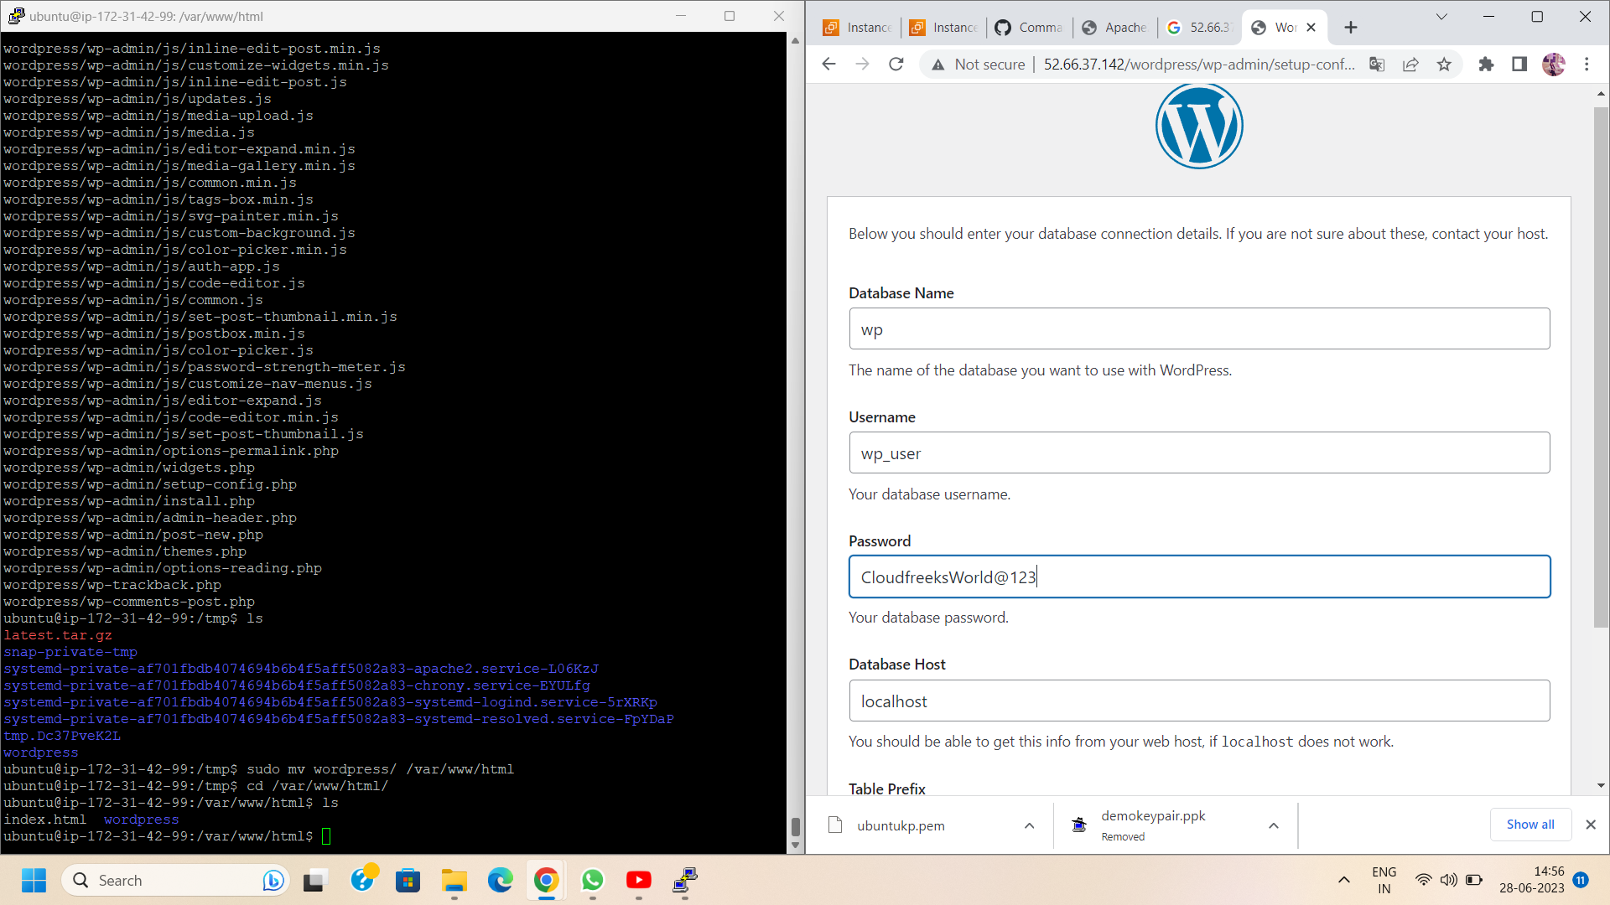

Step 14: Before proceeding, ensure that you have completed all the necessary steps to configure your website. This includes providing details such as username, password, and database host. Once you've filled in all the information, you'll be presented with a PHP code snippet.

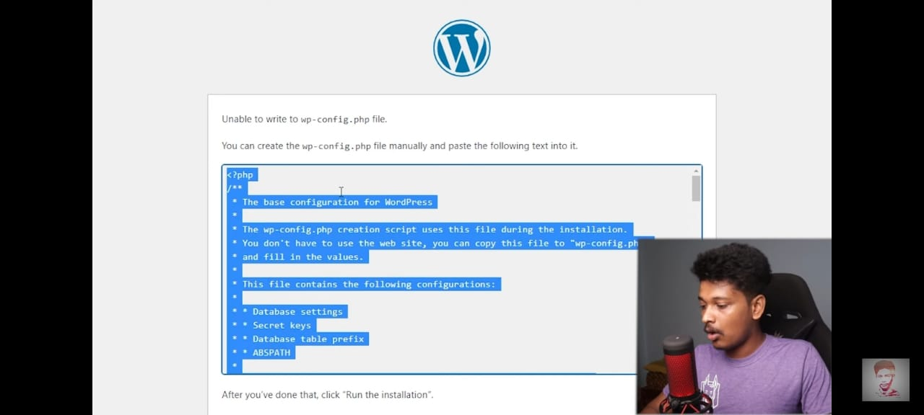

Step 15:The generated PHP code snippet is crucial for establishing the connection between your website and the server.Carefully copy the entire code provided.

Step 16:Now that you have the PHP code in hand, it's time to switch to your Ubuntu server. Open a terminal or command prompt and connect to your server using SSH (Secure Shell).

Step 17: Once connected to your Ubuntu server, navigate to the directory where you want to place the PHP code. This directory should be accessible by your web server and suitable for hosting your website. You can use the cd command to navigate through the directory structure.(e.g., cd wordpress/ )

Step 18: Now create a new php file to paste the code in it.Use the following command :

nano wp-config.php

Step 19: In the nano file, paste the PHP code snippet that you previously copied. Double-check for any syntax errors or missing characters to avoid any issues during the configuration process.

Step 20: After pasting the PHP code, save the file in the directory and exit the text editor. Execute the PHP code using the appropriate command, depending on the specific requirements of your website. This will initiate the setup and establish the necessary connections between your website and the server.

Step 21:Now switch to your wordpress server on the browser and press “Run the installation”. A new page will open “information needed”. fill all the valid information of your website and click the “install wordpress” button .

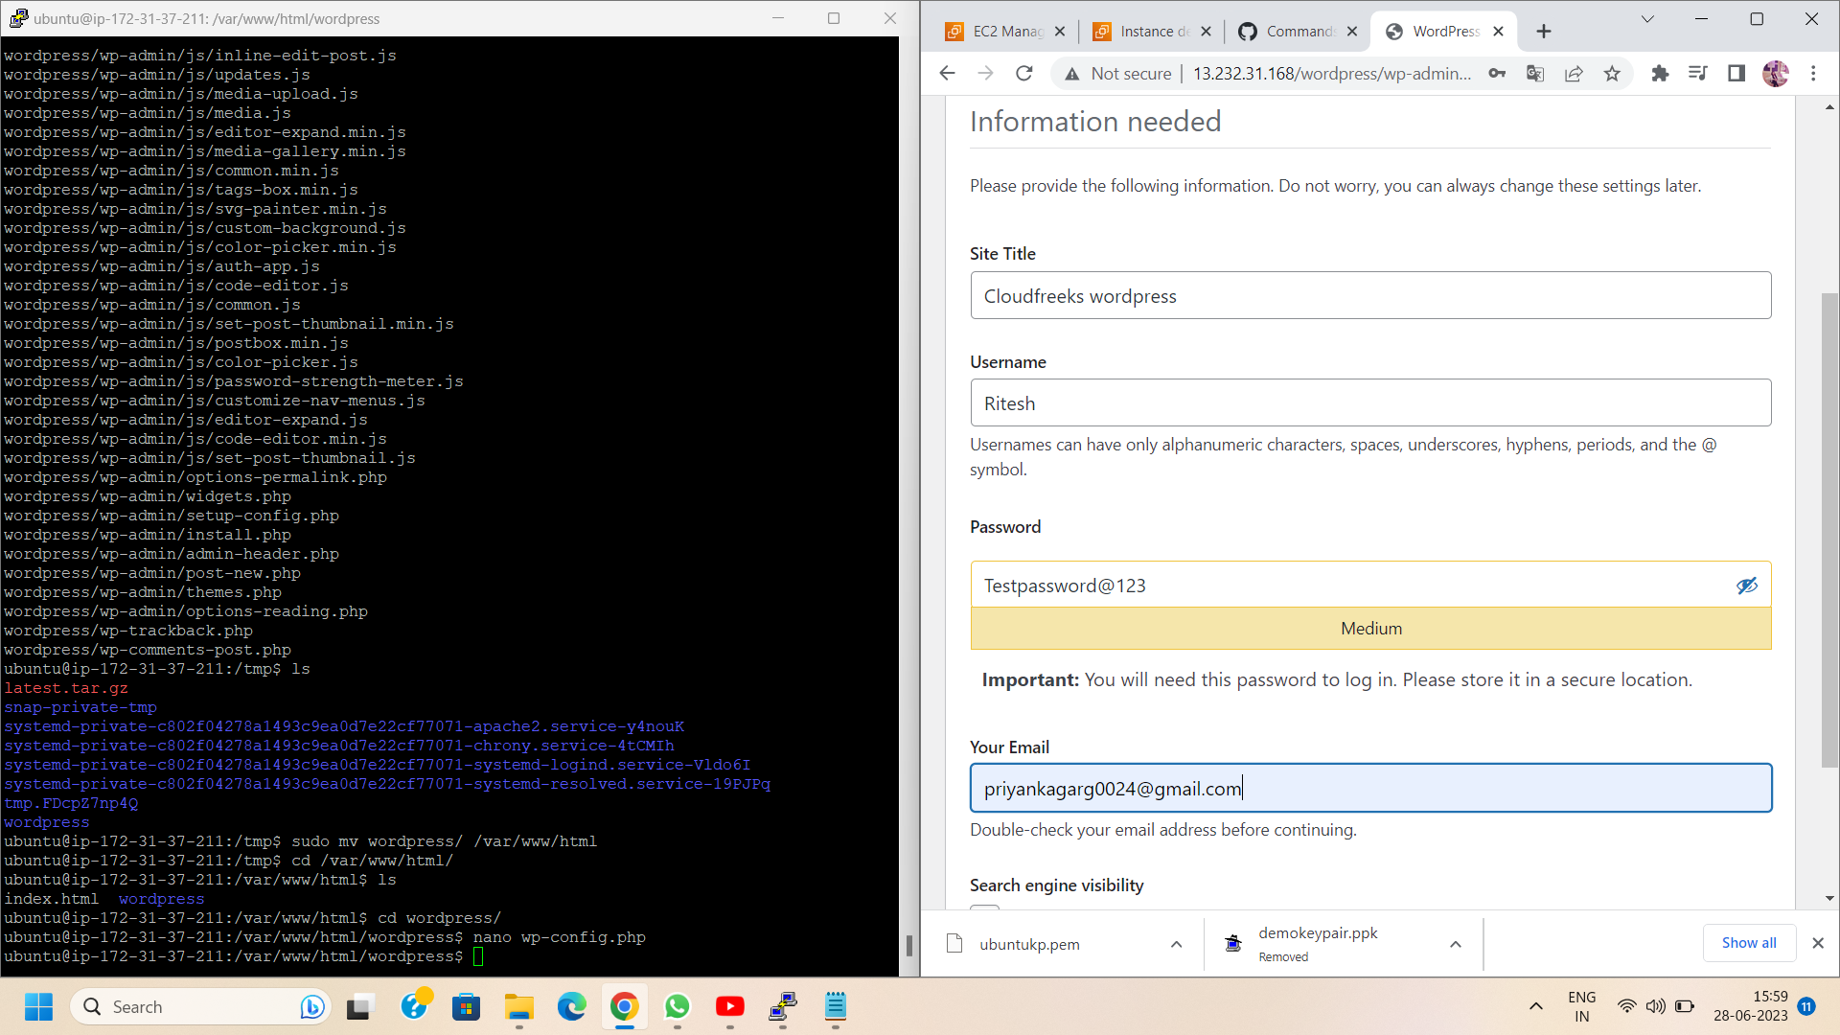

Step 22: Now, go to the browser and enter your server's public IP address followed by "/wordpress."(e.g.52.66.37.142/wordpress).Here you will get you wordpress website

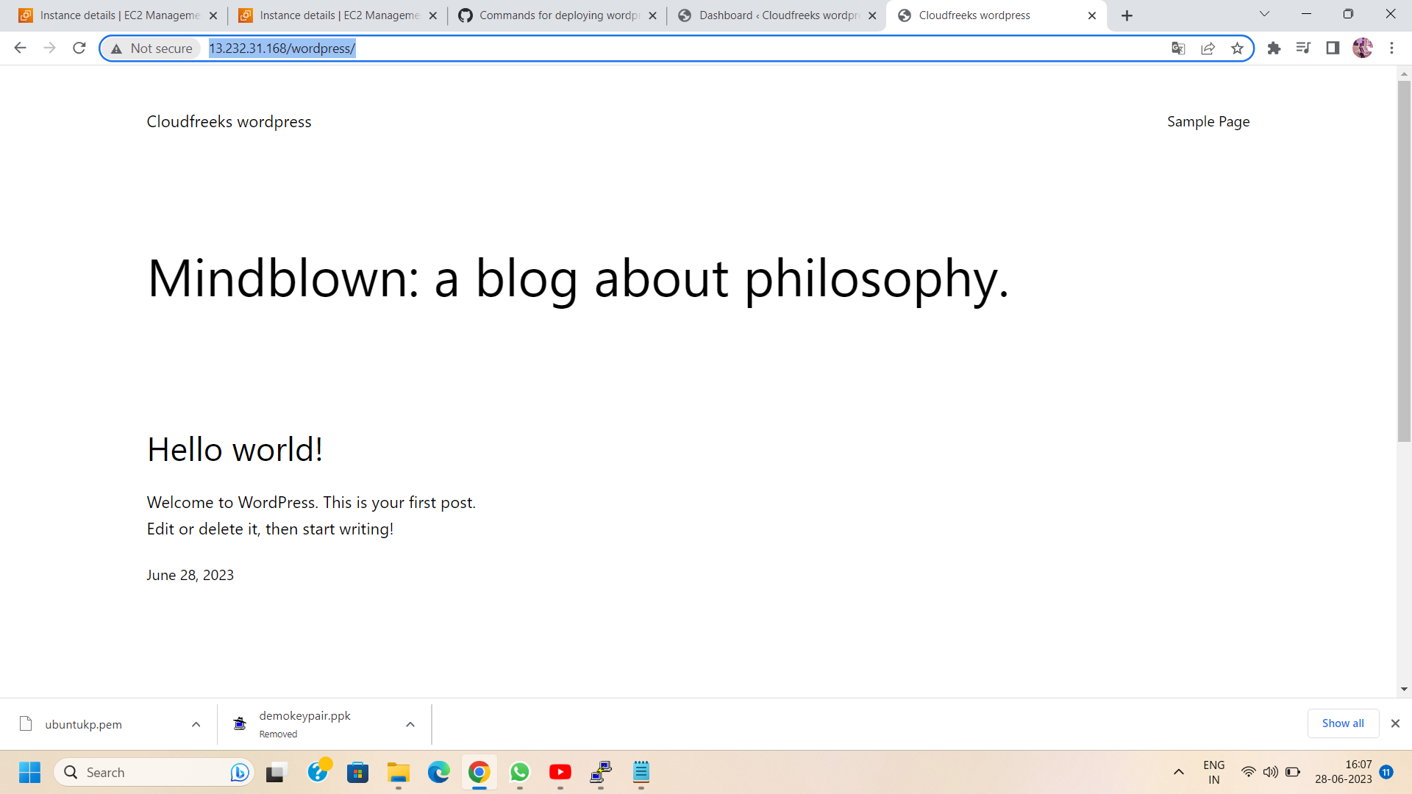

Conclusion:

By following these steps, you can effortlessly access your WordPress website by entering your server's public IP address followed by the "/wordpress" URL in your web browser. Take a moment to appreciate the fruits of your labor and explore the website you've created. Enjoy the convenience and ease of accessing your WordPress website, and continue to build an engaging online presence. Happy browsing!